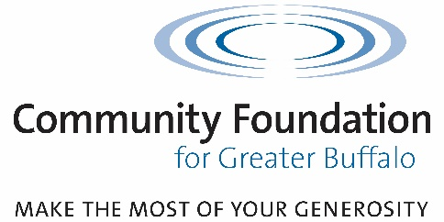

PROJECT PLAY WNY

2024 Summer Free Play Series

Grant Information and Schedule

- This grant is specifically for joining the Project Play WNY Summer Free Play Series for 2024. The goal for the series is providing youth in all 8 counties of Western New York opportunities to play, have fun, and enjoy Free Play!
- Applications MUST be submitted electronically online. No paper, emailed, or pdf applications will be accepted. Outcome reporting will also be online when closing the grant.

Eligibility
- Applicants must be in the 8 counties of Western New York:
  - Allegany
  - Cattaraugus
  - Chautauqua
  - Erie
  - Genesee
  - Niagara
  - Orleans
  - Wyoming
- Applicants must be serving youth (especially ages 5-14.)
- Applicants should fall into one of the following categories:
  - Qualified non-profit 501(c)(3)
  - Schools
  - Local governments and agencies

Other Matters
- PPWNY requires that all programming take place during Summer 2024
- PPWNY requires that all grants be closed out within one year of the receipt of funds
- The failure of an applicant to properly close out a grant in a timely manner will be a factor when considering new grant applications.

Timeline
Application opens online: March 4, 2024
Application deadline: April 5, 2024, at 4PM
NOTE: Applications in draft form after the deadline will be considered abandoned and will not be eligible to be considered for funding.
Decision notification: May 1, 2024

For grant-related and technical questions, please contact Ballin at 716-852-2857,

x 253 or jamesb@cfgb.org

Grant Application Questions
- Project name
- Amount requested
- Description of organization
- Date grant required
- Five-year history of prior grant requests to the Community Foundation
  - Previous requests, date submitted, and action (approved or denied) taken on each
- Financial background of organization including:
  - Annual operating expenses
  - Last fiscal year surplus/deficit
  - Accumulated surplus/deficit
  - Endowment market value

PROJECT DESCRIPTION
- Current Grantee of Ralph C Wilson Jr Foundation?
- Weekly Programming
  - Will there be a consistent day and time each week?
- Open Access
  - Indicate the number of individuals to be served by the proposed project.
- Non-Traditional Sport Offerings
  - Will there be options for youth to engage with non-traditional sport offering as an individual or as part of a group?
- Multi-generational Engagement
  - Will there be opportunity for family members, care takers and guardians to engage with youth during free play?
- Accessibility
  - Will the space and activities be accessible for youth of any ability?
- Culminating Event
  - Will there be a culminating event which is open to the public to mark the end of the season?
- What will be done?
  - What actions/activities are proposed to meet this need?
  - What are the distinctive features of your approach/program?
  - Is collaboration a part of this application? If yes, please detail.
  - What is the timetable?

PROJECT BUDGET
- Provide a very specific complete budget breakdown, identifying costs of the individual items that constitute your funding request to the Foundation
- Budget narrative (optional)
- If PPWNY were only able to partially fund your request, can you proceed?
  - If yes, how would your programming be affected? Please detail.
- What investment is your organization making in this project?
- Other funding sources from whom funds have been requested and the status of these requests
- If ongoing, what are your plans for continuing funding?

CERTIFICATION OF GRANT ELIGIBILITY
- Certification that the executive director and a board officer have approved submittal of the grant request and that all information provided is accurate
- Confirmation that organization has a Conflict of Interest policy in accordance with New York State Law
- List of all board members

ATTACHMENTS
- Resumes or CVs of project personnel – required

